Init coef.:

Gammap = 23.8888897\*10^-3;

Gammam = 24.5506112\*10^-3;

j0p = 7.40600014\*10^-3;

j0m = 8.08399963\*10^-3;

Preparation:

The data have been divided by the maximum value of all elements of the set.

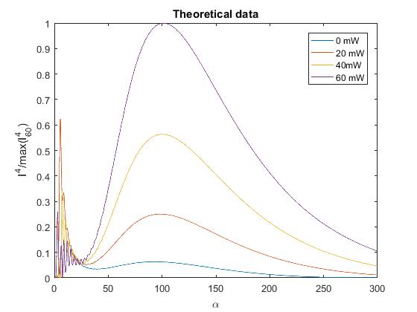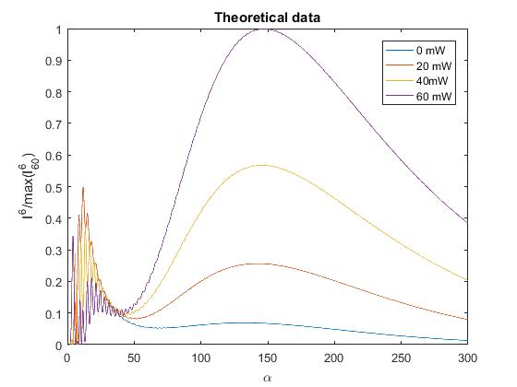

6th harmonic

4th harmonic

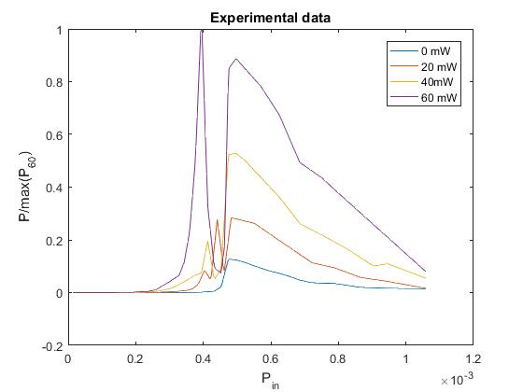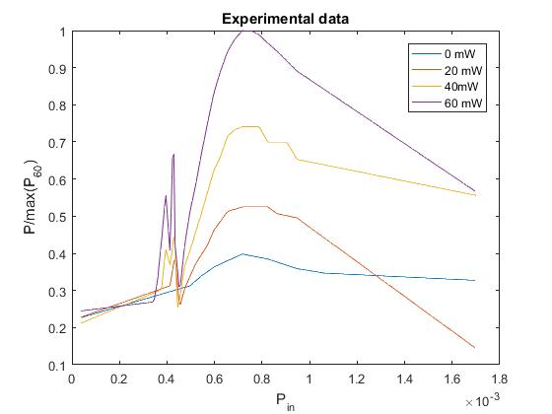

Results:

The α has been calculated for every point of experimental set (300 points).

Calculation time is approx. 17 minutes. The time was obtained because a set of theoretical data was obtained in advance.

Results

4th harmonic

6th harmonic

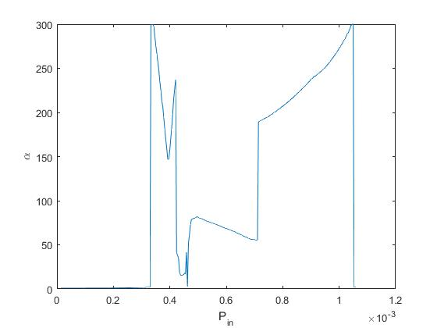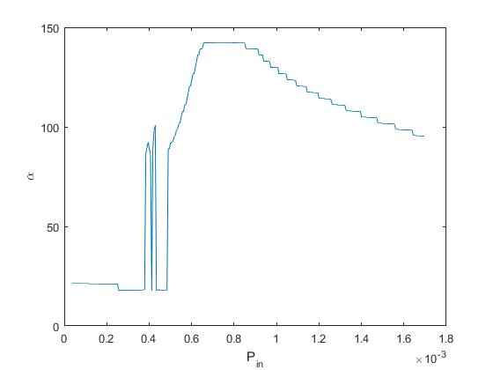

The difference of experimental data and theoretical data for selected α-value

